

External Users – How to Create a New Pathways Account

Objective | To provide a detailed procedure for external users to create a new account in DGS Pathways.

Step | Action
1 | Click the link to visit the DGS Pathways website.  https://learning-dgs.csod.com/login/render.aspx?id=orim  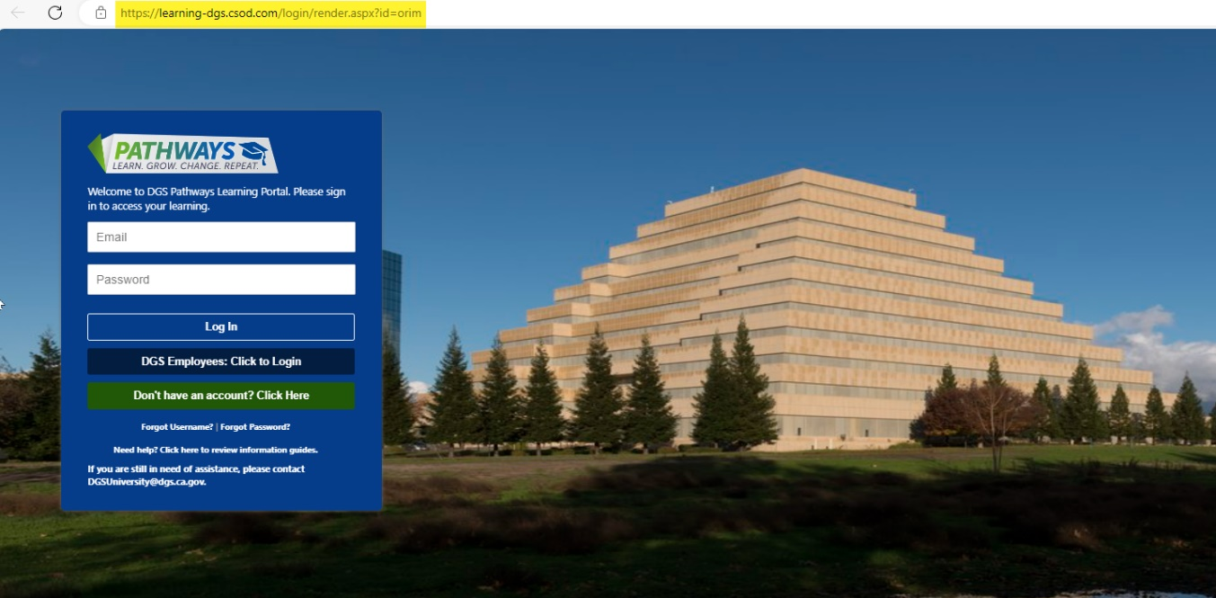
2 | Click on Create an Account. You will be directed to the self-registration page, which will open another screen.  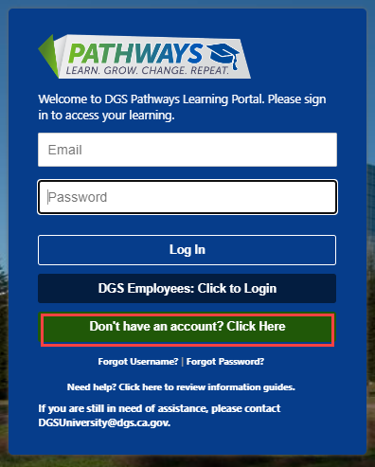

3 | Enter the following details into the appropriate fields:  - *First Name  - *Last Name  - *Email Address  - Classification/Working Title  - *Department Name  - *Office/Unit Name  - *Phone Number  - Address  - City  - State  - Zip Code  - *Entity Type (State, Federal, Company)  - *Username – Email Address will automatically populate as your Username    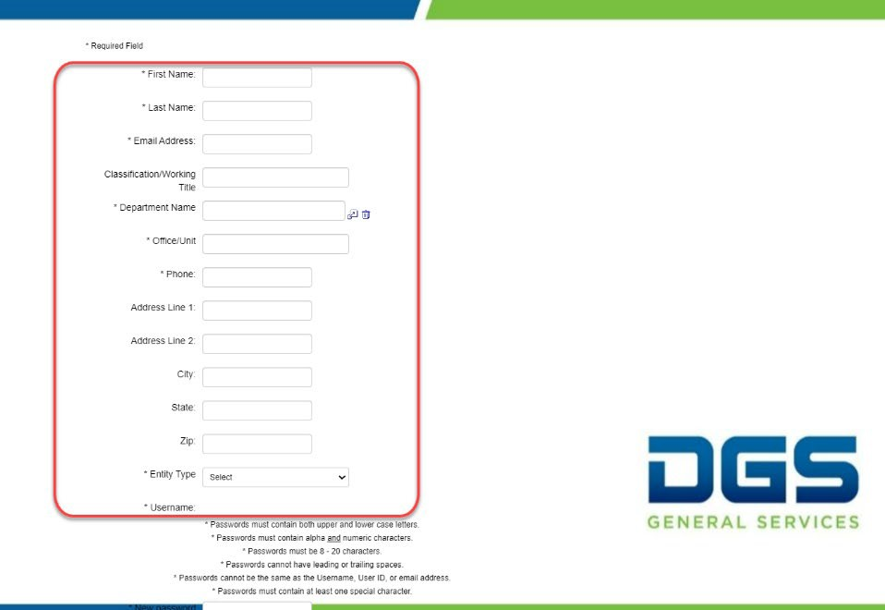  *Mandatory Fields

4 | At the bottom of the page, you will create a new password.  Passwords must:  - Contain both upper and lower-case letters.  - Contain alpha and numeric characters.  - Be 8-20 characters.  - Contain at least one special character.  Passwords cannot:  - Have leading or trailing spaces.  - Be the same as the Username, User ID, or email address.    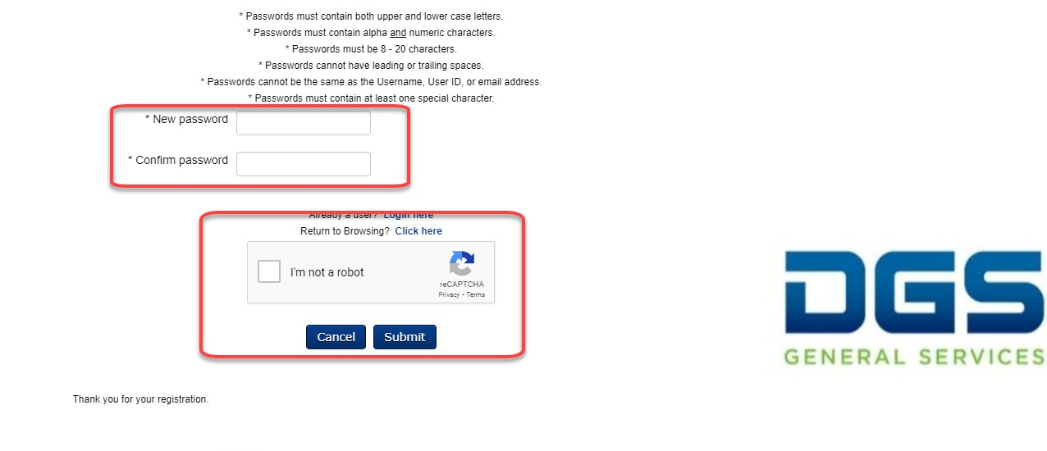  Check the box that says I’m not a robot to complete the “reCAPTCHA.”
5 | Click Log In.  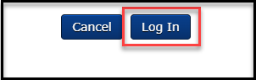

6 | This will log you into Pathways. Please remember your email and password for future use.  