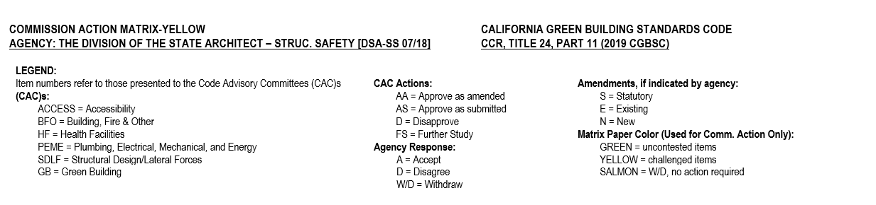

GREEN CODE ADVISORY COMMITTEE (DSA/SS)

CHAPTER 5, NONRESIDENTIAL MANDATORY MEASURES
DSA proposes to co-adopt the revisions made by the CBSC during the 2016 Intervening Code Cycle for Chapter 5, Division 5.1, Section 5.106.8, Light Pollution.
Item Number 6 | Code Section | Type of amend-  ment  (S, E, N) | CAC:  (AS, AA,  D, FS,  STFS) | Agency Response to CAC  (A, D, W/D) | 45-Day Comments  (AS, AA, D, FS) | Annotations | CBSC Action (AS, AA, D, FS)
 | 5.106.8 & items 1-4 and Notes 1 , 2 & 3 | E/N | AS | A | Christopher Uraine; Energy Solutions, representing Statewide Utility Codes & Standards Team (SUCST)  Recommends: AA | Amend items 1-4 and amend notes to create notes 1 and add new note 2.  CAC: recommended to add a Note 3 and to coordinate with BSC based on CEC discussion at the meeting to address additions and alterations found in Part 6.  45-Day: Approve as Amended.  DSA disagreed with the commenter see FSOR for responses.

CHAPTER 5, NONRESIDENTIAL MANDATORY MEASURES
DSA proposes to adopt new Section 5.107 requiring shade trees at public schools and community colleges
Item Number 7 | Code Section | Type of amend-  ment  (S, E, N) | CAC:  (AS, AA,  D, FS,  STFS) | Agency Response to CAC  (A, D, W/D) | 45-Day Comments  (AS, AA, D, FS) | Annotations | CBSC Action (AS, AA, D, FS)
 | SECTION 5.107  SHADE TREES | N | AS | A | 45-day comments:  Dereck Schubert- Trees of Oakland;  Recommends: AA  J.A. Townsend-Jacobs;  Recommends: A  Sharon Danks-GSA representing 16 organizations;  Recommends: AA  Sharon Danks-GSA;  Recommends: AA  15-day comments:  Sharon Danks-GSA representing 16 organizations;  Recommends: AA | 45-Day: Approve as Amended & Approve  DSA: See FSOR for responses.  15-Day: Approve as Amended.  DSA: See FSOR for responses.
 | 5.107.1 Shade trees | N | AS | A | 45-day comments:  Dereck Schubert- Trees of Oakland;  Recommends: AA  J.A. Townsend-Jacobs;  Recommends: A  Sharon Danks-GSA representing 16 organizations;  Recommends: AA  Sharon Danks-GSA;  Recommends: AA  15-day comments:  Sharon Danks-GSA representing 16 organizations;  Recommends: AA | 45-Day: Approve as Amended and Approve  DSA: See FSOR for responses.  15-Day: Approve as Amended.  DSA: See FSOR for responses.
 | 5.107.1.1 w/ Exception | N | AS | A | 45-day comments:  Dereck Schubert- Trees of Oakland;  Recommends: AA  J.A. Townsend-Jacobs;  Recommends: A  Sharon Danks-GSA representing 16 organizations;  Recommends: AA  Sharon Danks-GSA;  Recommends: AA  15-day comments:  Eric Carbonnier-HMR;  Recommends: AA  Sharon Danks-GSA representing 16 organizations;  Recommends: AA | 45-Day: Approve as Amended & Approve  DSA: See FSOR for responses.  15-Day: Approve as Amended.  DSA: See FSOR for responses.
 | 5.107.1.2 w/ Exception | N | AS | A | 45-day comments:  Dereck Schubert- Trees of Oakland;  Recommends: AA  J.A. Townsend-Jacobs;  Recommends: A  Sharon Danks-GSA representing 16 organizations;  Recommends: AA  Sharon Danks-GSA;  Recommends: AA  15-day comments:  Diane Aren-OSFM;  Recommends: AA  Sharon Danks-GSA representing 16 organizations;  Recommends: AA | 45-Day: Approve as Amended & Approve  DSA: See FSOR for responses.  15-Day: Approve as Amended.  DSA: See FSOR for responses.
 | 5.107.1.3 w/ Exception | N | * | * | 45-day comments:  Sharon Danks-GSA representing 16 organizations;  Recommends: AA  15-day comments:  Eric Carbonnier-HMR;  Recommends: AA  Sharon Danks-GSA representing 16 organizations;  Recommends: AA | *This section was inadvertently omitted from the 45-day CAM table.  45-Day: Approve as Amended & Approve  DSA: See FSOR for responses.  15-Day: Approve as Amended.  DSA: See FSOR for responses.

