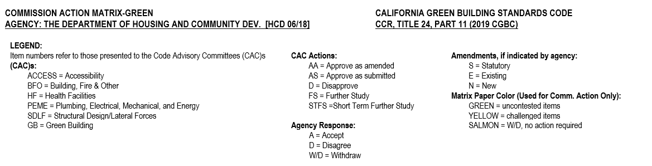
GREEN CODE ADVISORY COMMITTEE (HCD)

CHAPTER 1, sectION 101
Adopt amendments listed below
Item Number 1 | Code Section | Type of amend-  ment  (S, E, N) | CAC:  (AS, AA,  D, FS, STFS) | Agency Response to CAC  (A, D, W/D) | 45-Day Comments  (AS, AA, D, FS) | Annotations | CBSC Action (AS, AA, D, FS)
 | 101.1 Title | E | AS | A |  | Amend
 | 101.3.1, Item 3 | E | AS | A |  | Editorial change
 | 101.4 Appendices | E | AS | A |  | Amend
 | 101.8 Item 3 | E | AS | A |  | Amend
 | 102.3 ; HCD | E/N | AS | A |  | Added language and note

CHAPTER 2-DEFINITIONS
Adopt amendments listed below
Item Number 2 | Code Section | Type of amend-  ment  (S, E, N) | CAC:  (AS, AA,  D, FS, STFS) | Agency Response to CAC  (A, D, W/D) | 45-Day Comments  (AS, AA, D, FS) | Annotations | CBSC Action (AS, AA, D, FS)
 | 202 ACCESSORY DWELLING UNIT | N | AS | A |  | New definition added
 | 202 ACCESSORY OCCUPANCIES | N | AS | A |  | New definition added
 | 202 ACCESSORY STRUCTURE | N | AS | A |  | New definition added
 | 202 ALTERNATE WATER SOURCE | N | AS | A |  | New definition added
 | 202 JUNIOR ACCESSORY DWELLING UNIT | N | AS | A |  | New definition added
 | 202 ON-SITE TREATED NON-POTABLE GRAY WATER | N | AS | A |  | New definition added
 | 202 MERV | E | * | A |  | *Post CAC HCD: proposes to amend the definition based on CEC recommendations and HCD staff analysis. No formal action was taken by the CAC.

CHAPTER 3, GREEN BUILDING
Adopt amendments listed below
Item Number 3 | Code Section | Type of amend-  ment  (S, E, N) | CAC:  (AS, AA,  D, FS, STFS) | Agency Response to CAC  (A, D, W/D) | 45-Day Comments  (AS, AA, D, FS) | Annotations | CBSC Action (AS, AA, D, FS)
 | 301.1.1 Note | E | AS | A |  | Repeal note
 | 302.1 ; Exception 1 & 2 | E/N | AS | A |  | New exceptions added

CHAPTER 4, Residential mandatory measures
Adopt amendments listed below
Item Number 4 | Code Section | Type of amend-  ment  (S, E, N) | CAC:  (AS, AA,  D, FS,  STFS) | Agency Response to CAC  (A, D, W/D) | 45-Day Comments  (AS, AA, D, FS) | Annotations | CBSC Action (AS, AA, D, FS)
 | 4.106.2 Storm Water… Note | E/N | AS | A |  | Add a new Note
 | 4.106.4 Electric Vehicle…Exception 3 | E/N | AS | A |  | Add new exception 3
 | 4.106.4.2 New multifamily dwellings | E | AS | A | Richard Corey, Executive Officer; CARB  Recommends: AS | Amend  CARB supports 45-day language.  See FSOR for response
 | 4.106.4.2.1 Electric vehicle charging space (EV space) locations.  And Items 1 & 2 | E | STFS | A |  | Amend  CAC: STFS
 | 4.106.4.2.1.1 Electric vehicle charging stations (EVCS) & Exception | E/N | AS | A |  | Amend to add new heading to existing regulation and add new exception
 | 4.106.4.2.5 Identification;  Notes 1- 3 | E | AS | A |  | Amend to repeal Notes 1-3
 | 4.106.4.3.6 Accessible EV spaces; Notes 1-4 | E | AS | A |  | Amend to repeal Notes 1-4
 | 4.303.1 Water conserving plumbing fixtures and fittings; Note | E/N | AS | A |  | Amend to add new Note
 | 4.303.1.4.3 Metering faucets | E | AS | A |  | Amend
 | 4.304.1 Outdoor potable water use in landscape areas | E | AA | A |  | Amend  CAC: See HCD Addendum #1
 | 4.507.2 Heating and air-conditioning system design;  Items 1 & 2 | E | AS | A |  | Amend

CHAPTER 6, referenced organizations and standards
Adopt chapter with amendments listed below
Item Number 5 | Code Section | Type of amend-  ment  (S, E, N) | CAC:  (AS, AA,  D, FS,  STFS) | Agency Response to CAC  (A, D, W/D) | 45-Day Comments  (AS, AA, D, FS) | Annotations | CBSC Action (AS, AA, D, FS)
 | 601.1 ACCA,ANSI, & NSF standards | E | AS | A |  | Update referenced standards

CHAPTER 7, INSTALLER AND SPECIAL INSPECTOR QUALIFICATIONS
Adopt chapter without amendments
Item Number 6 | Code Section | Type of amend-  ment  (S, E, N) | CAC:  (AS, AA,  D, FS,  STFS) | Agency Response to CAC  (A, D, W/D) | 45-Day Comments  (AS, AA, D, FS) | Annotations | CBSC Action (AS, AA, D, FS)
 | Chapter 7 | E | AS | A |  | Adopt without amendments

CHAPTER 8, COMPLIANCE FORMS, WORKSHEETS AND REFERENCED MATERIALS
HCD does not adopt chapter 8
Item Number 7 | Code Section | Type of amend-  ment  (S, E, N) | CAC:  (AS, AA,  D, FS,  STFS) | Agency Response to CAC  (A, D, W/D) | 45-Day Comments  (AS, AA, D, FS) | Annotations | CBSC Action (AS, AA, D, FS)
 | Chapter 8 | E | AS | A |  | HCD continues to not adopt Chapter 8

appendix a4 residential voluntary measures
Adopt chapter with amendments listed below
Item Number 8 | Code Section | Type of amend-  ment  (S, E, N) | CAC:  (AS, AA,  D, FS, STFS) | Agency Response to CAC  (A, D, W/D) | 45-Day Comments  (AS, AA, D, FS) | Annotations | CBSC Action (AS, AA, D, FS)
 | A4.106.5.3 | E | AS | A |  | Amend
 | A4.106.8 | E | AS | A |  | Amend
 | A4.106.8.2  Tier 1 and  Tier 2 & notes  1 -3 | E/N | AS | A |  | Repeal main paragraph and add new Tier1 and Tier 2 language. Repeal notes 1-3.
 | A4.106.8.2.1 | N | AS | A |  | Add new code section
 | A4.106.8.3 ; Tier 1 & Table A4.106.8.3.1 | N | AS | A |  | Add new code section, Tier 1 & New Tier 1 Table
 | A4.106.8.3 ; Tier 2 & Table A4.106.8.3.2 | N | AS | A |  | Add new code section, Tier 2 & New Tier 2 Table
 | A4.302.1 Definitions;  Alternate Water Source; On-site treated non-potable gray water & Reference Evapotranspiration  ( ETo) | E | AS | A |  | Add new definitions and real existing definition
 | A4.304.2 Potable water elimination | E | AS | A |  | Amend
HCD 06/18-8.8.1 | a4.506.1 Filters Reserved | E | AS | A |  | CAC: See HCD Addendum #1
HCD 06/18-8.8.2 | A4.506.2 | E | AS | A |  | CAC: See HCD Addendum #1

