|  |  |
| --- | --- |
| Conferma Pay App Registration Guide | |
| Statewide Travel Program |

**Content**

1. Registering for the App 3

1.1 Download the app 3

1.2 Enter your Details 3

1.3 Verify Email 4

1.4 Security Question 5

1.5 Complete Registration 5

2. Logging into the App 6

2.1 First Time Logging In 6

2.2 Using Biometrics to Log In 7

2.3 General Logging in 7

2.4 Forgotten Password 8

3. Where to Find Information 10

3.1 Traveler 10

3.2 Travel Coordinator 11

4. Resend Communication from the App 13

5. Help 16

# Registering for the App

You can register for the Conferma App using the Conferma Registration portal.

**Note:** If you are already a registered user of any of the Conferma portals, you can go straight to log in using your existing username and password. You will not need to register for the app, unless you are using a different email address to access the app.

## Download the app

To access the Conferma Registration portal, do one of the following:

* + - Download the Conferma App from your App Store.
    - Tap the ‘Register’ link on the app’s ‘Sign in’ screen to open the ‘Registration’ portal.

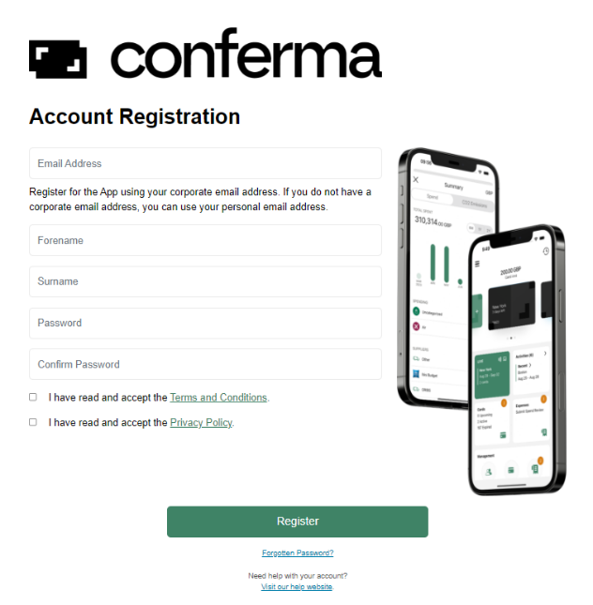

## Enter your Details

* Email address—ensure this is the email address that your invite link was sent to.
* Forename
* Surname
* Password
* Confirm password—this needs to match exactly the password you entered in the ‘Password’ field.

When you have successfully entered your details and clicked ‘Register,’ you will see the confirmation page:

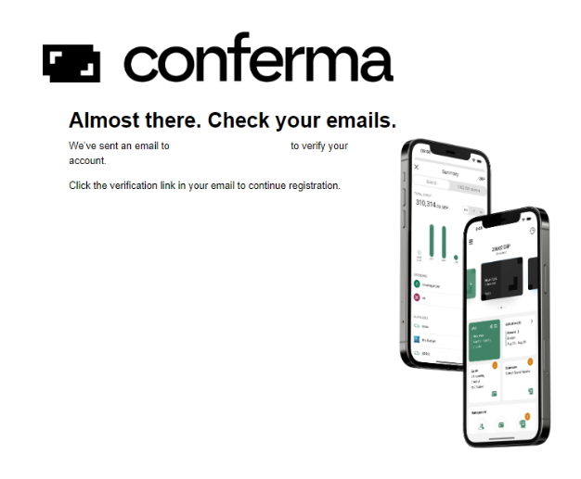

## 1.3 Verify Email

Check the email account that you registered with for a verification email and click ‘Verify my email’ to complete your registration. Alternatively, click the hyperlink in the email.

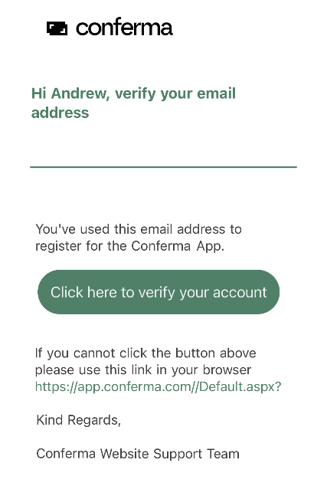

**Note:** If a user who has registered for the app, but not yet verified their email address, attempts to log in, they will be redirected back to the login screen with a message prompting them to check their emails.

**Warning:** The link in your email is only valid for two hours. If the link expires, you will need to begin the registration process again.

## 1.4 Security Question

When you click the above-mentioned link, you will be asked to enter the password you chose earlier. You will also need to choose a security question and answer to be used if you forget your password and need to set a new one.

There are four standard security questions that you can choose from, or if you prefer, you can also set your own question.

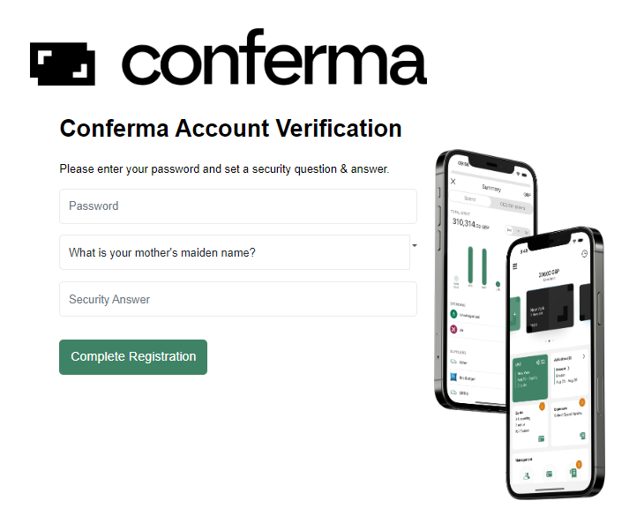

**Tip:** Choose a security question that would be difficult for others to guess the answer to, but ensure it is something that you will remember when you need it.

## 1.5 Complete Registration

When you have completed the form, click ‘Complete registration.’ If your registration has been completed successfully, you will see this screen:

|  |
| --- |
| This image showing that your account setup is complete! |

# Logging into the App

## 2.1 First Time Logging In

When logging into the app for the first time, enter your email address and the password you chose at registration and tap ‘Sign in.’

If you are logging in for the first time, or the terms and conditions have been updated since you last logged in, you will need to accept the terms and conditions before you can proceed.

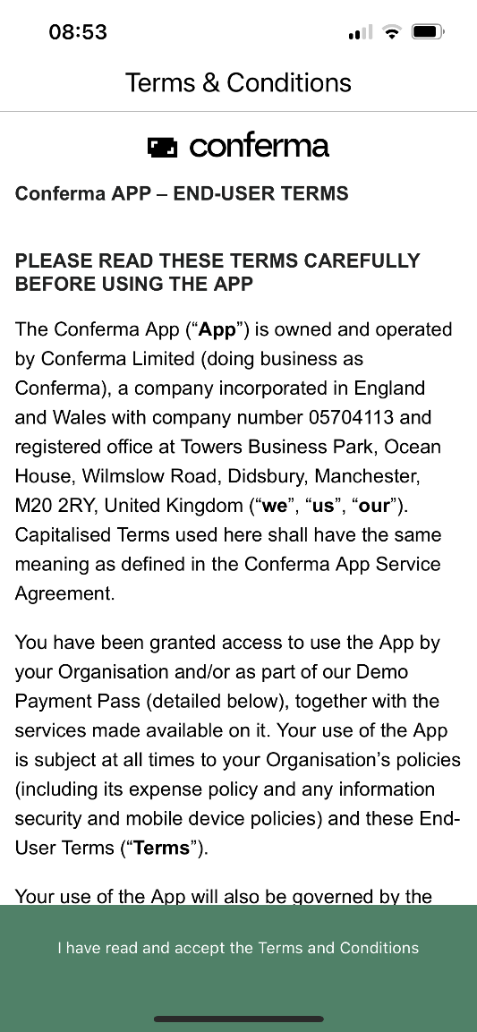

You will be asked to provide your mobile number for verification the first time that you sign in.

Click ‘Continue,’ and a verification code will be sent via SMS to the mobile number you provided. The verification code may take up to two minutes to be received, and you cannot request a new code until at least two minutes have passed.

Enter the code into the verification screen. If you enter the code incorrectly, you will be able to re-enter it without needing a new code.

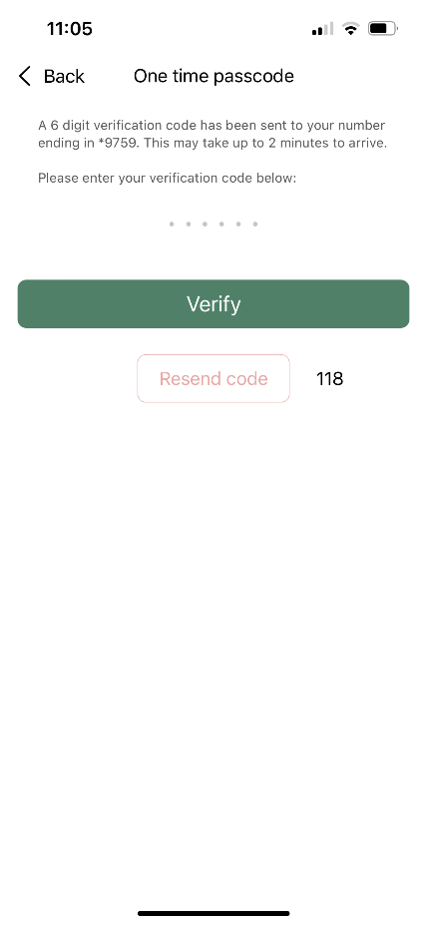

**Warning:** The verification code will only be valid for 15 minutes. After this time, you will need to request a new code by tapping the Resend code link.

## 2.2 Using Biometrics to Log In

If you have biometrics such as fingerprint or facial recognition enabled on your device, you will be prompted to accept them as an authentication method for the Conferma App.

**Note:** You will be able to log in using your biometric for 90 days from your last log in to the Conferma App. After 90 days, or after an app update, you will need to complete the full log in process as described here, including receiving an SMS verification code.

## 2.3 General Logging in

If you are already a registered user of any of the Conferma portals, you can use your existing login details to log in to the Conferma App.

## 2.4 Forgotten Password

If you have forgotten your password or your account has been locked, click ‘Forgotten password’ on the login screen.

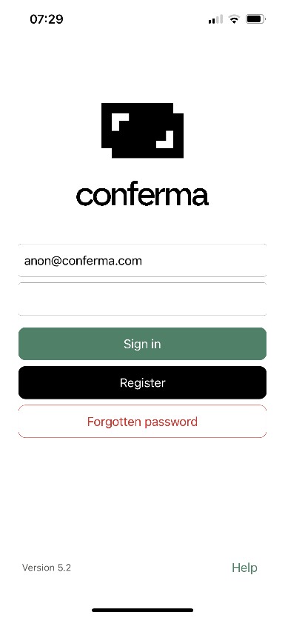

Enter your email address and the answer to your security question.

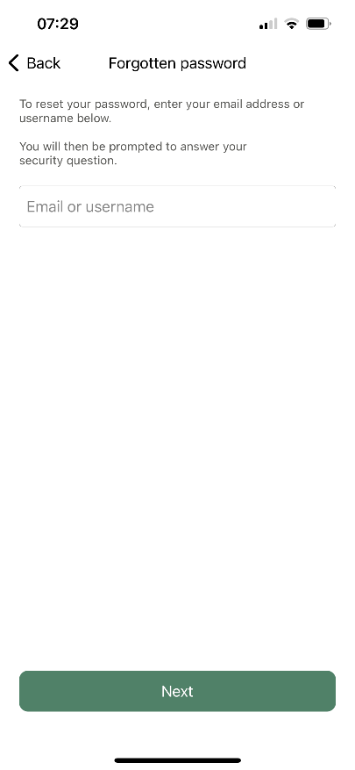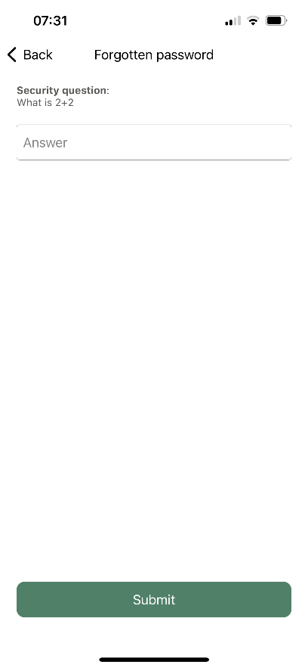

You will then receive an email containing a temporary link that will redirect you to the ‘Registration’ portal. Re-enter your security answer and then create a new password. Click ‘Reset Security Details’ to save your new password.

**Warning:** You must ensure that your chosen password contains at least 8 characters and at least one of the following: upper case letter, lower case letter, number, special character.

# Where to Find Information

## 3.1 Traveler

When a hotel card is created in Conferma Online for a Conferma App user, an activity will be created with the hotel card linked.

As a traveler, tap the activity from the home screen. If the activity is not active yet, tap ‘Activities’ and then find the activity.

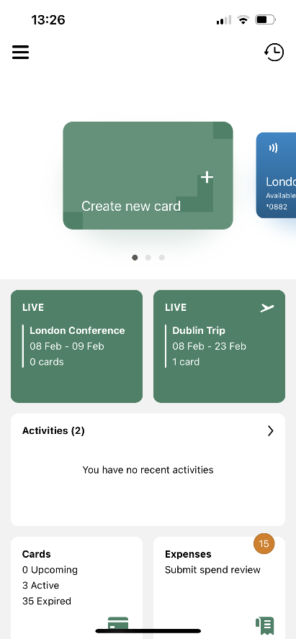

**Note:** The card will be sent to the traveler immediately. If the active dates are in the future, the card will be inactive until the specified dates.

## 3.2 Travel Coordinator

A hotel booking is created when a card is created with a deployment type of hotel and booking information is provided from an integrated travel booking system or manually entered in Conferma Online.

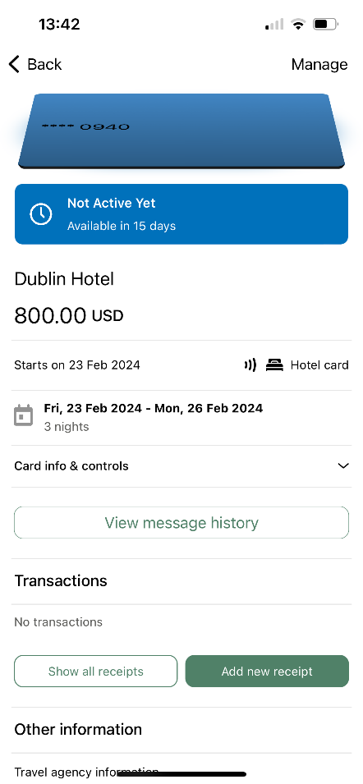

When a hotel booking is created in Conferma Online an activity will be created. In the Conferma App you will be able to view the following information:

* Card details—you can only view these during the check-in and departure dates of the booking
* Booked amount—total booking amount
* Supplier name—hotel name
* Address details—the full address of the hotel. Tap the address to view a full screen map
* Supplier reference—hotel confirmation reference, if available
* Check in/Check out—the dates of your stay
* Room type—the room type name or code, if available
* Rate information—any rate information provided by the travel system, if available
* Cancellation policy—the cancellation policy, if provided
* Payment restrictions—details of what costs can be charged to your virtual card

The Conferma App also displays the optional travel agency details such as:

* Travel management company logo (or TMC name if not available)
* Support telephone number
* Support email address

You can see the deployment ID that you will need for support queries at the bottom of each card screen.

# Resend Communication from the App

Once a booking has been made, users can choose to resend communications or authorizations from the Conferma App.

From the home screen, tap ‘Cards.’

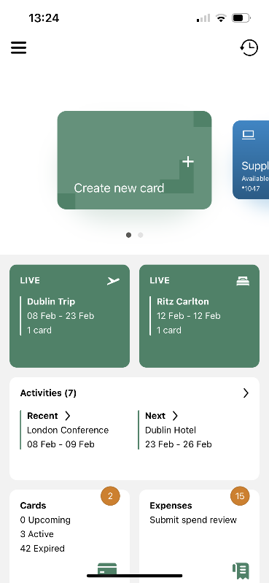

Tap the accommodation card that you want to resend communications/authorizations for.

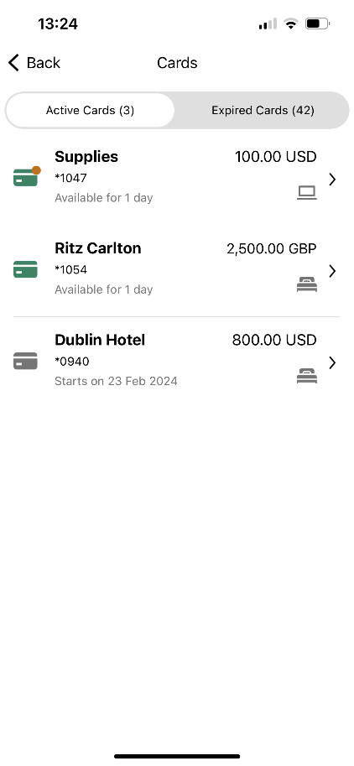

Scroll down the page and tap ‘Send authorization.’

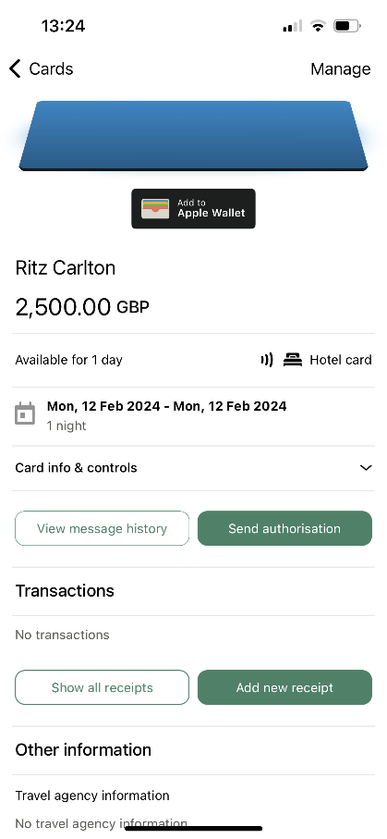

Tap ‘Add email address or fax’ to add a new email address or fax if the communication/authorization has not been received as expected.

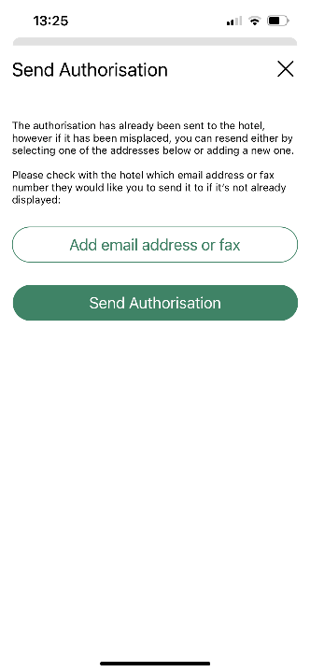

Enter the correct email address or fax number and tap ‘Add.’

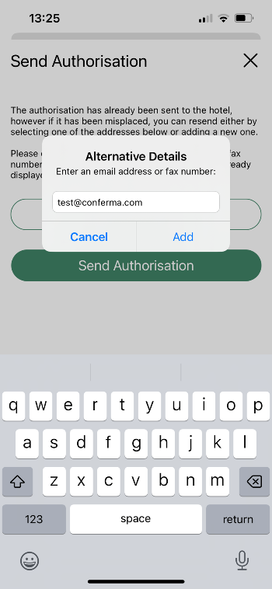

Tap ‘Send authorization.’

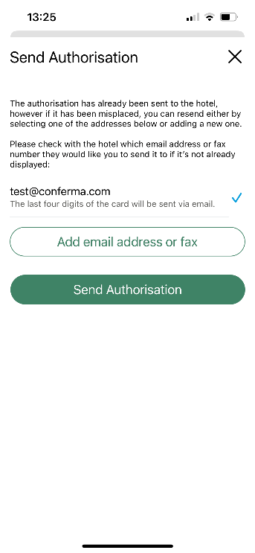

# Help

If you have a question with the app, please contact Conferma at [appusers@conferma.com](mailto:appusers@conferma.com)

Help Links: Users can click the help links within the App or on the Registration site (app.conferma.com), which will direct them to an email window to request support.

For general Conferma questions, please contact the Statewide Travel Program at [statewidetravelprogram@dgs.ca.gov](mailto:statewidetravelprogram@dgs.ca.gov).