Government Claims Program

Frequently Asked Questions

General Questions

Why can’t I open the claim form(s)?
You may be using an unsupported browser that blocks our downloads. Please try downloading our forms using Google Chrome. Microsoft Edge, Safari, and Firefox may run into complications.
If your issue is about an older version of Adobe or opening the download you may need another version. See below for links to some other file formats that might be more accessible for your computer or device.
GCP Claim Form (ORIM 006) | PDF | Word Doc| JPEG
Filing Fee Waiver (ORIM 005) | PDF | Word Doc | JPEG
If you need a form mailed to you, please reach out to us through gcinfo@dgs.ca.gov with your mailing address, and we will make sure we can get a copy to you.

What if I hit a pothole? What if my windshield was damaged on a State Highway?
Damages can include:
- Potholes
- Debris hitting windshield
- Construction damage
First, ensure that the roadway where the incident occurred is owned or controlled by the state. GCP doesn’t have access to this information. You may be able to access this info from the city, county, or Caltrans district where the incident occurred. Please reach out to them to confirm.
Next, you want to determine how much your damages are worth.
Claims for $12,500 or less need to be filed directly with Caltrans. (…)
Claims for more than $12,500 can be filed with the Government Claims Program.
Please include any repair estimates or receipts to support your claim.
---
If you would like to file a claim with GCP regarding pothole damage or damage caused by debris on a CA highway, your claim must meet the following requirements:
- The damages must equal $12,500 USD or more, and you must be able to prove this, for example, through an invoice from an auto shop assessing the damages and the cost needed to fix them
- The damages must be caused by a state entity (i.e. Department of Transportation) to be under GCP’s jurisdiction. For a list of all state entities please click here.
If it only meets one of the requirements, please click here to file your claim with the Department of Transportation.
If you mistakenly file a claim with us, your claim risks getting rejected with no compensation.

I filed a claim with CalTrans. Where is it?
If your claim was submitted directly to Caltrans, you must contact Caltrans to follow up. Please click here to find the contact information for the appropriate Caltrans District. Or you may call Caltrans Headquarters at (916) 654-2852.
If your claim is against Caltrans but filed with us at GCP please refer to How Can I check the Status of My Claim? For how to get updates on your claim.

How can I tell if I filed with GCP or another agency?
There are a few ways to tell who your claim has been filed with! You can check:
- The way the claim form looks
- The claim number that was assigned
- The mailing address the claim was sent to

Claim Form Appearance
The claim form for the Government Claims Program looks like the one below. Check for the label “DGS ORIM 006” to confirm that it is our claim form.
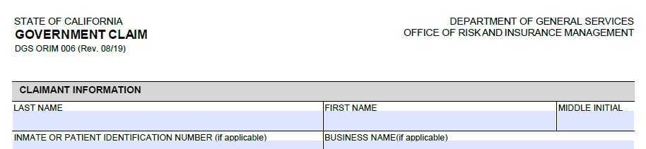
If you submitted a form like this:
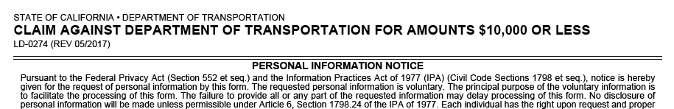
Please note that the Caltrans claim form says ‘$10,000 or less’, but the limit is actually $12,500
You may have submitted a form for CalTrans to our office, which would then be forwarded to them. You can reach out to CalTrans to check with them by clicking here and reaching out to the appropriate district.

The Claim Number
All claims filed after March 1, 2022, are assigned a claim number starting with “GCP”.
If your claim number looks different than the examples below, you may have filed a claim with a different department.
GCP Claim Number Examples:
GCP202300612
GCP-21008734

Mailing Address
The Government Claim Program’s mailing address is:
Government Claims Program
P.O. Box 989052, MS 414
West Sacramento, CA 95798-9052
If this is the location that you sent your form to, then it has been filed with GCP. Any other address would be long to another agency.
If you sent your claim here, but the form is not ORIM 006, then our staff may have forwarded it to the appropriate department to be filed with them.

Claim Requirements

May I get help filling out the claim form?
GCP Staff is not legally authorized to represent claimants. If you need help, filling out the form, we recommend you have someone you trust, or an attorney represent you.
We do have resources to assist you in understanding our forms:
Links inserted here

What do I need to file a claim with GCP?
The information needed to file a claim with the Government Claims Program is below:
- Claimant’s name and mailing address
- Inmate ID (only required for individuals housed in state facilities)
- The name and mailing address of the person representing you, if you have chosen to be represented.
- The date the event occurred which made you want to file a claim
- A general description on the damage, injury, or financial loss
- The name(s) of the state entity or employee causing the damages
- The dollar amount you believe you are owed
  - Please make sure you provide an explanation and support for the amount
- A signature by the representative or claimant
  - We accept e-signatures
- A $25 filing fee per claimant listed or a filled Fee Waiver or Fee Reduction Request Form (ORIM 005)
Please do NOT submit the following:
- Social Security Numbers
- Original documents
- Entire medical records or bills
- Banking information
- Birth, Marriage, and/or Death certificate
GCP scans documents received and destroys the originals, so we cannot return original documents to you. If we need any extra information or proof to help your investigation, our staff will reach out to you.

I have a lot of additional informational that can’t be mailed? What do I do?
For security reasons, please don’t submit CD’s flash drives, (…)
External links, secured e-mails (i.e. Dropbox) cannot be accepted

How do I submit my claim form?
Compile your claim form, supporting documentation, and filing fee or fee waiver form and mail these papers to:
Government Claims Program
P.O. Box 989052, MS 414
West Sacramento, CA 95798-9052
We will reference the post date or the date when the mail was sent out for your deadlines. You can also drop your claim at the drop box at the address:
707 3rd Street
West Sacramento, CA 95798-9052
Currently, GCP only accepts claim submission via postal mail or our drop box. We can’t accept an e-mailed claim form as an official submission.

What if I have no inmate ID?
An inmate ID is only required for filing a claim if you are housed in a state institution. Please submit the form without this information if it does not apply to you.

What if I don’t know the amount to claim?
Your claim can’t be processed without an amount. If you believe the total exceeds $10,000 USDS indicate whether the claim is a limited civil case (less than $25,000) or a non-limited civil case (above $25,000) by checking either box on the form.
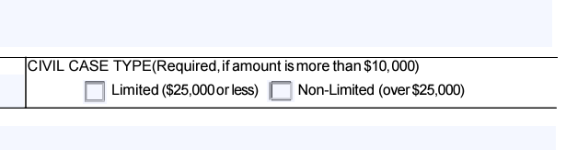
Otherwise, you can get an estimate of the cost of damages by a professional.

How do I file with multiple claimants?
You can choose to fill out one GCP form and add the names of the additional claimants using extra paper. Please note that every additional claimant must pay another filing fee of $25.
For example: 2 claimants
2 x $25 = $50

Is my claim meant for the Government Claims Program?
If you believe you have suffered damages that total over $100 USD and were caused by a California State agency, you can file a claim with our program. Otherwise, please contact the agency directly.
Unsure what entities are considered state entities? You can click here for a list of all state agencies in California and their contact information.
Additionally, some agencies also handle claims themselves if they are up to $1000 USD in damages. If your claim is against any of these agencies and the damages total $1000 or less, please file directly with them:
- California Highway Patrol
- Department of Consumer Affairs
- Department of Motor Vehicles
- Department of Corrections and Rehabilitation
- Department of State Hospitals
If you mistakenly file a claim with us, your claim risks getting rejected with no compensation.

How do I fill out my check for the $25 filing fee?
Please fill the check as you normally would. For Pay to the Order of, write “The State of California” and for the memo please write “GCP Claim” or “GCP filing fee” and then the name of the claimant, so that if the claim gets separated from the check, we can still match the two together. If you know your claim number, you can also include that in the memo line too. See the example below.
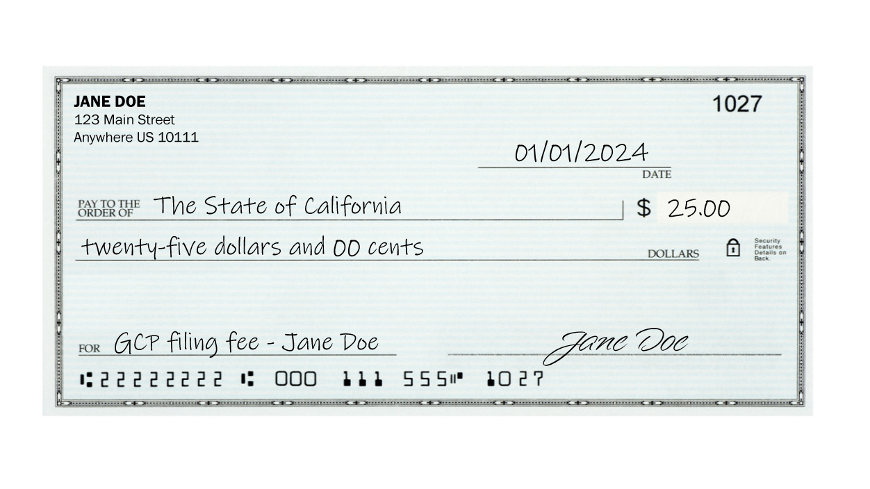

Claim Process Expectations

How long does the claims process take?
The Government Claims Program processes claims on a case-by-case basis, so there is no set amount of time for a claim to be resolved.
When the GCP receives a claim, staff determines if it meets the needs for sufficiency, jurisdiction, and timeliness. Often, the program works together with the named department to reach a solution. When this investigation is opened, it can take some time between GCP and the other department to make sure all the facts line up. Then, GCP uses this information to create a recommendation for the claimant.
NOTES: Timeliness link it to the deadlines section. Jurisdiction -> GCP’s authority to decide (link that to the is my claim meant for GCP).

How can I check on the status of my claim?
You can check on claim status by calling (916) 376-5302, e-mailing gcinfo@dgs.ca.gov, or writing to our mailing address: Government Claims Program P.O. Box 989052, MS 414 West Sacramento, CA 95798-9052.
Please make sure you allow for at least 1 month before following up on your claim status. Once claim investigation starts, you will receive a notice via mail to the address you provided on your claim form.
GCP receives lots of mail and phone calls. Emailing gcinfo@dgs.ca.gov is usually the best way to get questions answered!

How do I make amendments to my claim?
Amendments are accepted by email or postal mail.
You can send attachments to gcinfo@dgs.ca.gov with your claim number and “Amendment” as the subject line, if known. Otherwise, please provide the name of the claimant who the claim is filed under and the date of incident so we can easily find your claim.

Claim Exceptions

I am filing a claim as/for a small business. How do I fill out a GCP claim form?
GCP uses a single claim form for a variety of claims we accept, so please use the claim form (ORIM 006) and fill the necessary fields as appropriate.
- Claimant Name: Business Representative First and Last Name
- Business Name
- Telephone Number
- Email Address
- Mailing Address: address where notices should be sent to about the claim status
- Representative Information: fill out if you are being represented by an attorney; this contact information will be prioritized
- State Agencies or Employees against whom the claim is filed: State Agency the service was provided for
- Date of Incident: Date that payment was denied or when the business has reason to suspect that payment won’t be made
- Anything regarding “Damage or Injury” can be treated as “Debt”
  - If you provided a service to the state and are awaiting payment you can describe the service provided
- You may attach invoice information as supplemental documentation

I can’t afford the $25 filing fee. Can I still file a claim?
Of course! The Government Claims Program has a Fee Waiver or Fee Reduction Request form available. Please click here to download the form ORIM 005. You can fill out this form and attach it to your claim form for consideration of a reduced or waived filing fee.
For helping filling out this form please see our guide by clicking here.

Filing Deadlines

What deadlines exist for filing a GCP claim?
Claims for death or injury to a person, personal property, or growing crops must be filed within six months after the incident occurred. Any other claim must be filed within one year of the incident.

What if I want to claim damages that happened over a year ago?
If your claim should have filed within six months and you missed the deadline, you may request leave to present a late claim within one year of the date of incident by detailing your reason for filing beyond the deadline on the GCP claim form or in a supplemental letter.
The department must act on requests within 45 days. If the department does not take action within 45 days, the application is deemed denied.

When is a late claim request granted?
The department may allow a claim for any of the following reasons:
- Mistake, inadvertence, surprise or excusable neglect where the public entity was not prejudiced by the failure to file within the deadline
- Claimant was a minor during all the time allotted
- Injured claimant was physically or mentally incapacitated during all the time allotted and for that reason failed to file in time.
- Injured person died before the expiration of the time allotted for filing the claim

Claim Results

My claim has been delegated. What does that mean?
If you have been notified that your claim has been delegated,

What can I do if my claim was rejected?
If your claim was rejected, it doesn’t necessarily mean it’s the end of the line! It simply means that your claim cannot be resolved through GCP.
Sometimes, when GCP finds a claim should be dealt with in another way, we issue a rejection so that path can officially be opened up. A rejection from GCP, while harsh in tone, might mean you can get compensated for more through the court system.
NOTES: seek outside counsel/attorney

How long does payment take after a claim has been approved?
Once payment is approved for a claim, the named department is expected to issue payment.
A waiver and release form will be sent to you by the involved agency, and it must be signed and sent back for them to issue payment. The amount of time it takes to issue payment is determined by this process.
If you are still facing a delay in payment after this has been completed, please let us know and we can reach out to the department regarding your payment status.

