SCPRS Upload Procedures
- Log in to FI$Cal

- Click “Classic Home”
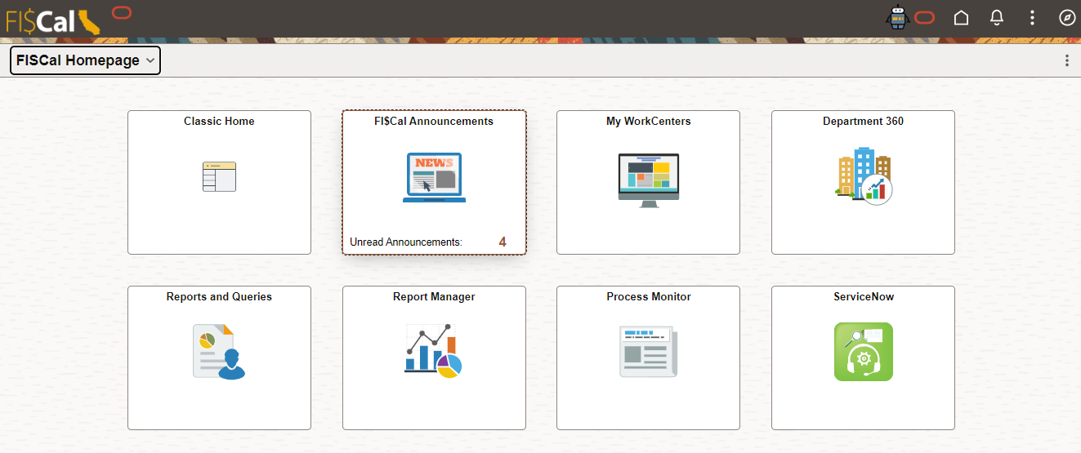
- Click “FI$Cal SCPRS”
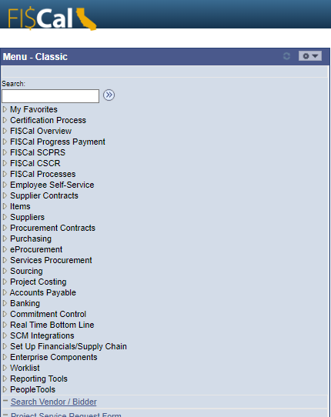

- Click “Run SCPRS Upload”
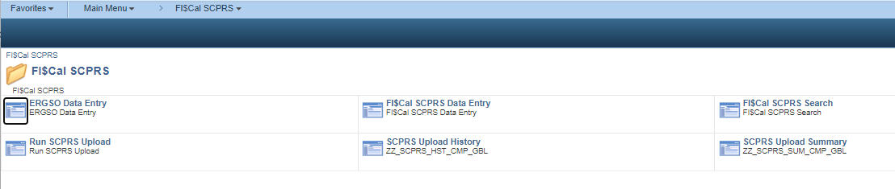
- Click “Add a New Value”
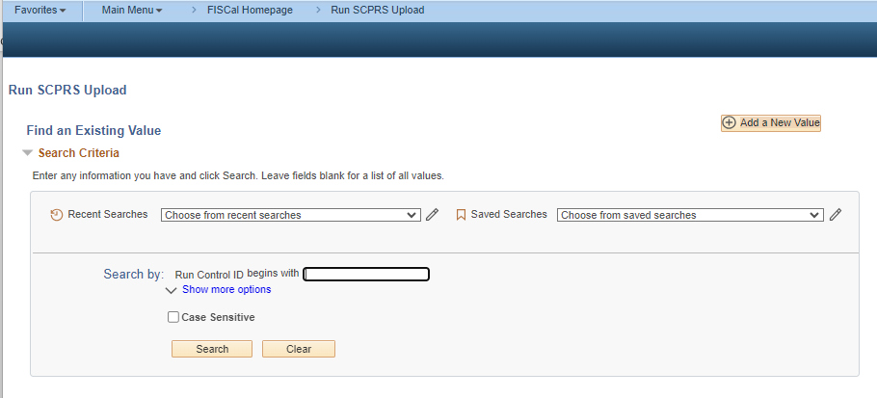

- In the Run Control ID field, enter a name for your Upload document
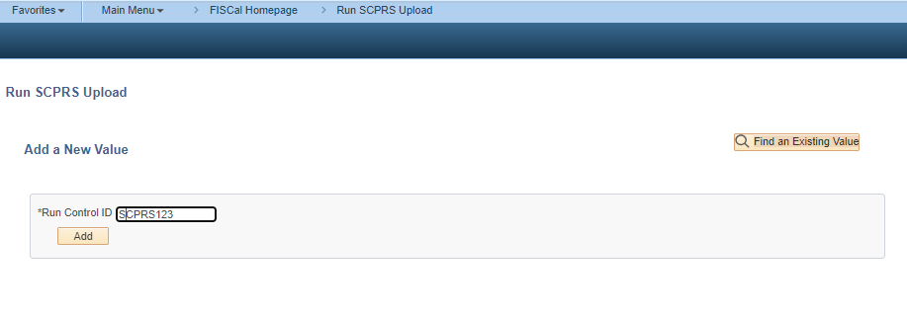
- Click “Add” button
- Enter your 4 digit Business Unit
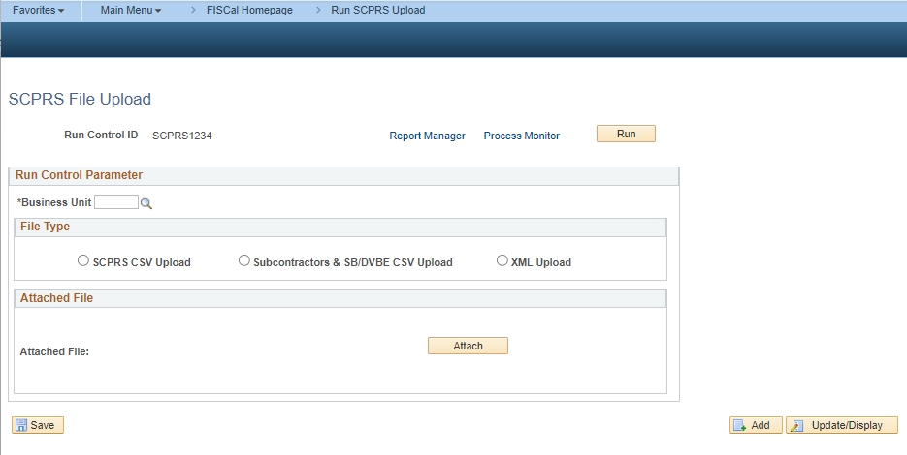
- Select “SCPRS CSV Upload” button
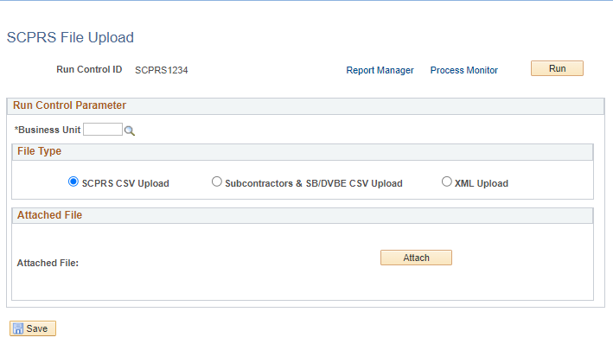

- Click “Attach”
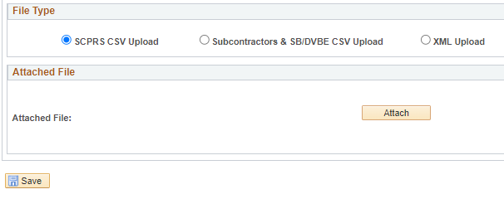
- Locate the CSV file provided by DGS eProcure SUPER Team
- Once selected, the file name will show.
- Click “Save”
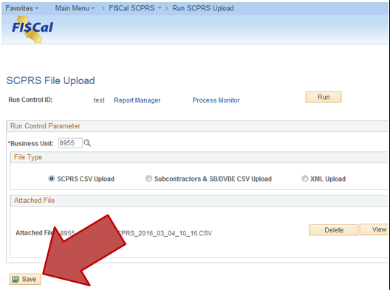
- Click “Run” and “Ok”

- Click “OK” (Do not change any values if you would like the upload to happen now.)
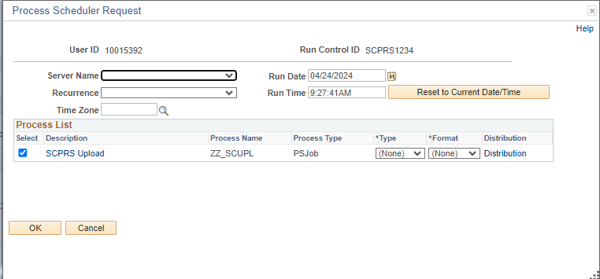
- Click Process Monitor hyperlink 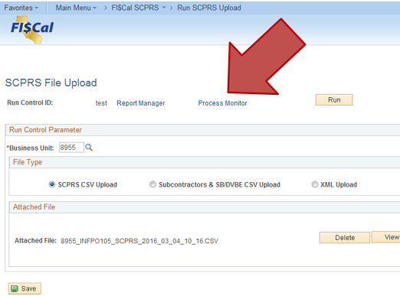

- From the Process Monitor page, click “Refresh” until Run Status and Distribution Status say Success and Posted.
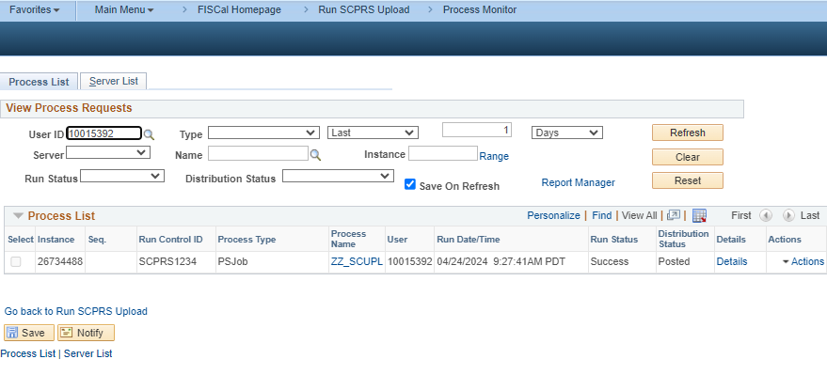
- Go to the breadcrumbs at the top of the screen and from “FI$Cal SCPRS” select “SCPRS Upload History”. This process may take a minute to run.
- Locate your Upload in the SCPRS Upload History. 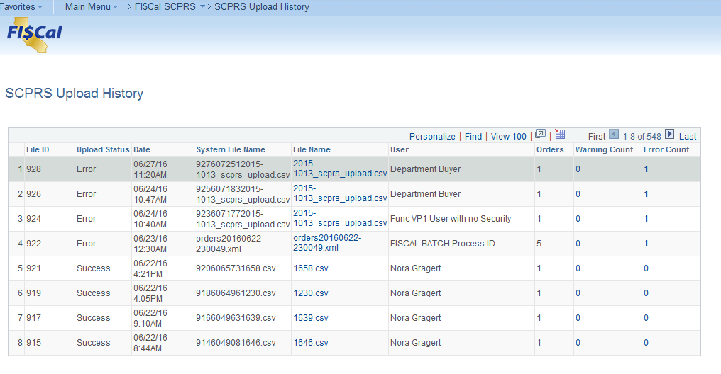
- Click on the Error Count hyperlink to view errors. 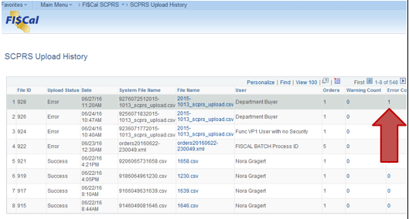
- The Error Log will show any POs which could not be uploaded due to errors.
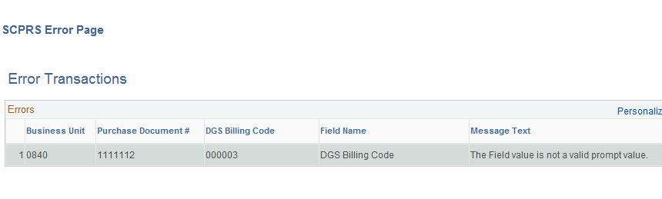
- From the CSV file used for the upload, delete all line items that DO NOT have an error.
- Correct the errors, or contact SUPER Team at eprocure@dgs.ca.gov for assistance.
- Once errors are corrected, return to Step 1 of this guide.
- If there are no Errors, the SCPRS Upload is complete.

